An alternative characterization of forest fire regimes: incorporating spatial patterns of stand-replacing patches

Brandon M. Collins1, 2*, Jens T. Stevens3, Jay D. Miller4, Scott L. Stephens3, Peter M. Brown5, Malcolm North1,6

1USDA Forest Service, Pacific Southwest Research Station, Davis, CA, 95618, USA

2Center for Fire Research and Outreach, University of California, Berkeley, CA, 94720 USA

3Ecosystem Sciences Division, Department of Environmental Science, Policy, and Management, University of California, Berkeley, CA, 94720 USA

4USDA Forest Service, Pacific Southwest Region, Fire and Aviation Management, McClellan, CA 95652, USA.

5Rocky Mountain Tree-Ring Research, 2901 Moore Lane, Ft Collins, CO 80526, USA

6Department of Plant Sciences, University of California, Davis, CA 95616, USA

*Author to whom correspondence should be addressed: e-mail: bcollins@berkeley.edu

**Abstract**

The proportion of fire area that experienced stand-replacing fire effects is an important attribute of individual fires and fire regimes in forests. It has been used to group forest types into characteristic fire regimes, as well as to assess departure from historical fires. However, relying on proportion alone ignores important spatial characteristics of stand-replacing patches, which can have a strong influence on post-fire vegetation dynamics. We propose a new more ecologically relevant approach for characterizing patterns of fire effects. We applied a simple modified logistic function to describe the relationship between the proportion of total stand-replacing patch area and an interior buffer distance on stand-replacing patches. This approach robustly distinguishes among different spatial configurations of stand-replacing area in both theoretical and actual fires. This can be calculated for individual fires and summarized for multiple fires over a given area, allowing for meaningful quantitative comparisons between individual fires and among regions.

**Introduction**

Departure in disturbance processes and patterns from historical (i.e., prior to Euro-American settlement) conditions is often the basis for contemporary ecosystem restoration efforts in dry conifer forest of western North America (Swetnam et al. 1999, Safford et al. 2012, Stephens et al. 2016). Assessing the degree of departure requires descriptions of contemporary (departed) and historical (natural) disturbance patterns. Remote sensing products allow for robust characterizations of contemporary fire severity patterns (e.g., Miller and Thode 2007). However, similar detail is lacking for historical fires. As a result, we rely upon coarser scale characterizations of historical fire severity patterns, which reflect average conditions across numerous fires; fire regime type (i.e., low, mixed, and high severity) is a readily used example of this (Agee 1998, Schoennagel et al. 2004).

Dendroecological reconstructions have provided a majority of the information from which historical fire regimes have been inferred (Fulé et al. 1997, Swetnam et al. 1999, Taylor 2004). These studies do well at characterizing the two extremes of historical fire regimes in forests: frequent, generally non-lethal surface fires (i.e., low severity), versus infrequent, generally lethal crown fires (i.e., high severity). Example forest types with these respective fire regimes include southwestern U.S. ponderosa pine (*Pinus ponderosa*) and Rocky Mountain lodgepole pine (*Pinus contorta*) (Schoennagel et al. 2004). However, the historical fire regime for many dry conifer forest types is somewhere in between these two extremes. These forests are described as historically having a mixed severity fire regime (Perry et al. 2011, Hessburg et al. 2016). Hessburg et al. (2016) define mixed severity as fires “where 20–70% of the dominant tree basal area or canopy cover of a given patch of forest is killed by any single instance of fire”. Forest types characterized as mixed severity historically had structures that were maintained by surface fire (i.e., large, widely spaced, early-seral trees) intermixed with discrete vegetation patches created by crown fire (i.e., shrubs, dense tree regeneration) (Agee 1998, Hessburg et al. 2016).

The occurrence of both surface and crown fire in the same forest type historically resulted in highly complex vegetation – fire interactions (Agee 1998, Collins and Stephens 2010). This complexity along with the wide amplitude in fire effects across a single fire (20-70% mortality) has led to uncertainty identifying the historical range of variation for forests characterized by a mixed severity fire regime (Perry et al. 2011). Recent uses of archived forest inventory datasets have led some studies to conclude that previous dendroecologically based estimates of historical stand-replacing fire effects were incorrectly low (Williams and Baker 2012, Odion et al. 2014). As a result, current departure in fire severity for these forest types is contested (e.g., Mallek et al. 2013). However, significant limitations of these archived forest inventory data have been identified (Fulé et al. 2013, Stevens et al. 2016), questioning the validity of the historical stand-replacing proportions proposed. This debate is not simply academic; it has strong implications for forest restoration throughout the western North America. If contemporary patterns of stand-replacing fire effects are within the range of historical variability, large-scale restoration programs (e.g., USDA-FS 2012) may be lacking a sound ecological underpinning.

Beyond the large range in fire effects captured in the mixed severity category, binning fire regimes into low, mixed, and high severity ignores important spatial characteristics of fires. In particular, the spatial patterns of stand-replacing patches, which can have a strong influence on post-fire vegetation dynamics in dry conifer forests (e.g., Kemp et al. 2016), are not addressed. In this paper we propose a new more ecologically relevant approach for describing spatial patterns of stand-replacing fire effects, which will improve the characterization of fire effects for individual fires and fire regimes. Our intent is to refine the current characterization of fire regimes, rather than replace it.

**Scale and “percent stand-replacing”**

Despite having widely used definitions for binning fire regimes based on percent stand-replacing (e.g., <20%, 20-70%, >70%; Agee 1993), there is considerable ambiguity in the scale at which these classes should be applied. At small spatial scales all fires in conifer forests will have patches of burned area in all three classes (Brown et al. 2008). Indeed, at the smallest possible spatial scale (the individual tree scale), there is no such thing as a mixed-severity patch: a tree is either killed or it is not. This suggests that this fire regime classification is more suited for coarser spatial scale assessments, such as summing percent stand-replacing (i.e. percent basal area mortality) for individual fires, or averaging it for multiple fires across a landscape (Agee 1998). However, simply summing or averaging, then binning into one of three categories provides no information on how the stand-replacing area is distributed spatially. Even within a given fire regime category the size, shape, and spatial distribution of stand-replacing patches can vary considerably, which can result in significantly different long-term ecological effects. One of the strongest effects is the influence on seed dispersal for different tree species. For example, ponderosa pine (*Pinus ponderosa*) has relatively heavy seed that generally does not disperse far from surviving trees, which can severely limit recovery into large stand-replacing patches (Chambers et al. 2016). In other words, an individual fire with small, widely scattered stand-replacing patches across the burned area is likely to have very different seral vegetation and rate of forest recovery than a fire with stand-replacing area aggregated in only a few larger patches (Kemp et al. 2016).

Most evaluations of contemporary fire severity rely on classifications of Landsat pixels by the change in vegetation reflectivity before and after fires (e.g., relative differenced Normailized Burn Ratio-RdNBR; Miller and Thode 2007). Using these satellite data calibrated to field plots, it is possible to assign categorical classifications of low, moderate and high severity fire *at the 30-m pixel scale* (Miller et al. 2009). Independent plot data sampled immediately before and one-year following wildfire demonstrate that a commonly used classification of RdNBR into low, moderate, and high severity corresponds with the following tree basal area mortality levels: 5-20%, 25-70%, and >95%, respectively (Lydersen et al. 2016). Although the range in mortality associated with moderate severity is fairly consistent with the previously used definition of “mixed-severity” (20-70% mortality), fires where a majority of the area is mapped as moderate severity are exceedingly rare (Miller and Quayle 2015). A more frequently observed pattern is that “mixed-severity” fires have some substantial (>20%) proportion of their area mapped as contiguous stand-replacing patches, amongst a matrix of low or moderate severity effects. It should be noted that even in boreal and subalpine forest types characterized by high severity fire regimes, contemporary fires very rarely have more than 70% of their area mapped as stand-replacing (e.g., Harvey et al. 2016).

These patterns suggest that a defining characteristic of fire regimes is not whether average percentages of overstory mortality fit in the commonly used classes (<20%, 20-70%, >70%), but rather it is the size and shape of contiguous stand-replacing patches. To illustrate this, we examined two recent fires in the northern Sierra Nevada (Figure 1). The 2012 Chips Fire in the Plumas National Forest burned with a modest overall proportion of stand-replacing fire (22%). Note, we used the “high severity” threshold described by Miller and Thode (2007), which is consistent with stand-replacing effects, i.e., >95% basal area mortality (Lydersen et al. 2016). This proportion of stand-replacing fire was very similar to the 2008 Cub Complex Fire (20%), which occurred 10km northwest of the Chips Fire. The patterns of stand-replacing effects, however, were distinct. Forty-three percent of the stand-replacing area in the Chips Fire was aggregated in contiguous patches that were larger than 250 ha, while for the Cub Complex only 24% was in the >250 ha class (Figure 1). Furthermore, stand-replacing area was relatively evenly distributed among patch size classes for the Cub Complex, but heavily skewed for the Chips Fire (Figure 1).

The potential impact of these different distributions of stand-replacing patch area on post-fire vegetation dynamics is significant. Large, contiguous and roundly-shaped patches of tree mortality have much more “core” area, which is the amount of stand-replacing area that remains greater than a given distance in from the patch edge (Cansler and McKenzie 2014). Smaller or elongated patches, on the other hand, have greater proportions of edge, and lesser distances-to-patch edge. For the Chips Fire, 33% of the stand-replacing patch area is >120 m from patch edges, compared to 17% for the Cub Complex (Figure S1). This contrast is ecologically relevant because the dominant tree species in this forest type (i.e., Sierra Nevada mixed-conifer) lack direct mechanisms for establishment following stand-replacing fire (e.g., vegetative re-sprouting or seed stored in serotinous cones). The significance of the 120 m threshold is that it exceeds the likely distance of seed dispersal for even the tallest mixed conifer trees in this area (McDonald 1980, Clark et al. 1999). This means that a considerable amount of the stand-replacing area in the Chips Fire will likely be void of natural conifer regeneration for an extended period of time (Collins and Roller 2013). While these different patterns may be related to the disparity in overall fire sizes (Chips: 30,898 ha; Cub: 7940 ha), they emphasize the importance in not only examining overall proportions of stand-replacing effects, but at patch sizes and the distribution of area among patch size classes.

**Alternate characterization of fire regimes**

Building on the ideas discussed around the two contrasted fires above, we developed a mathematical model to describe the relationship between stand-replacing patch area and distance from patch edge. Rather than simply plotting distributions of stand-replacing area by patch size class, we sought a more process-based characterization of these very different configurations. Given that in dry forests one of the primary factors limiting tree regeneration following a stand-replacing disturbance is seed dispersal, we focused on distance-to-patch-edge as an important variable influencing post-fire vegetation dynamics. The concept of “core patch area” is one approach that can address this. However, core patch area is a binary classification that depends on a single distance threshold. We extend this concept to describe a more continuous relationship between the proportion of total stand-replacing patch area and an interior buffer distance applied to stand-replacing patches (Figure 2). The proportion of original stand-replacing area remaining within a given internal buffer distance is necessarily bounded between 1 and 0 inclusive, equaling 1 when the internal buffer distance is zero (as all the original patch area remains), and equaling 0 when the internal buffer distance is equal to the maximum distance to edge within the largest patch. This relationship can be approximated for multiple irregularly shaped patches by a modified logistic function:

$P \sim \frac{1}{{10}^{SDC*Dist}}$ (Eq. 1)

where $P$ is the proportion of the original stand-replacing area, *Dist* is the internal buffer distance, and SDC a free parameter that describes the shape of the relationship which we call the *stand-replacing decay coefficient*. Larger values of SDC describe a more rapidly decaying proportional patch area, while smaller values of SDCdescribe more slowly decaying proportional patch area.

To illustrate this relationship, we generated four hypothetical scenarios of stand-replacing patches with identical areas and proportions of the landscape (Figure 2A-D). Each scenario had 1000 ha of area in stand-replacing patches, but scenario A had 1024 circular patches of 0.977 ha each, scenario B had 100 patches of 10 ha each, scenario C had 9 patches of 111 ha each, and scenario D had 1 patch of 1000 ha. The fitted values of SDC were 0.0219, 0.0068, 0.0020, and 0.0006 for scenarios A-D, respectively. This translates to predictions of the original stand-replacing area greater than 120m from the patch edge of <0.01%, 15%, 58% and 85% for scenarios A-D, respectively. SDC does not capture the complete loss of stand-replacing area with a large enough distance because the modified logistic function does not go to zero, but it is a very good approximation of the rate of loss of stand-replacing area with increasing distance from edge, which is the value of ecological importance. In addition, SDC appears to distinguish among the configurations with intermediate sized patches (Figure 2B and 2C), with corresponding intermediate SDC values (Figure 2E). The interpretation of these different distributions is that flatter curves depict greater proportions of stand-replacing area at larger distances from “green” forest edge. A similar example varying patch shape from elongated to round would display a similar difference in distributions, where rounder shapes or simpler patch edges that have larger distances to forest edge would have flatter curves than would more elongated patches or patches with more complex edges (Figure 3).

We tested the application of this approach with two actual wildfires. Because of the potential influence of total fire size on stand-replacing proportion and patch sizes (Cansler and McKenzie 2014) we chose a pair of similarly sized fires to compare stand-replacing area at different distances to patch edge. These fires, 1987 East Fire and 2008 Caribou Fire, occurred in the Klamath region of northwestern California, and had similar proportions of stand-replacing area (~5000 ha, 20% - Figure 4A). Unlike our hypothetical fires (Figure 2) both of these fires exhibited a range of patch sizes and shapes, so it was uncertain how well the univariate decay function would capture actual patterns of stand-replacing patches. Plots of both observed and fitted stand-replacing proportions as a function of interior distance were quite consistent (Figure 3B), suggesting this decay function could be applied to actual fires. The two example fires had noticeably different decay curves, with the East Fire having a much longer and flatter shape (Figure 3B). This shape reflects the disproportionate amount of area in large stand-replacing patches observed for the East Fire relative to the Caribou Fire. In the absence of post-fire vegetation management these two fires would be expected to have noticeably different landscape vegetation recovery and successional patterns, i.e., more coarse-grained or homogenous patterns for the East Fire. This reduction in fine-scale heterogeneity can significantly simplify post-burn conditions, reducing microclimate, habitat, and species diversity (Hessburg et al. 2016). It may also entrench alternate disturbance patterns as large stand-replacing burn patches are prone to re-burn at high intensity when wildfire returns (Coppoletta et al. 2016).

**Applications of this approach**

To further investigate the applicability of this new metric, we calculated the SDC for 436 fires that burned in California between 1984 and 2015. This included all California fires with mapped fire severity that were predominantly forested and >100 ha, regardless of the managing agency. The resulting values of SDC were approximately normally distributed after a log transformation (Figure 4), which appears to clearly distinguish the few select fires that have extremely small SDCs and thus have a very high proportion of their stand-replacing area far from the nearest patch edge. Not surprisingly, fires that are larger and have a higher proportion of stand-replacing effects tend to have smaller SDCs (Figure 5B, C). However, for any given fire size or proportion of stand-replacing area, there are still a wide range of potential SDC values, which illustrates potentially profound ecological differences among “mixed-severity” fires that might otherwise be considered very similar if percent stand-replacing were used as the relevant variable. Thus, SDC may be a reasonable integration of both of these variables, but it also contains additional information that is highly relevant to quantifying fire effects (e.g., distance to seed source).

Our approach of plotting stand-replacing proportions as a function of interior distance offers a relatively simple way to capture complex patterns of fire effects. The decay curves and associated SDC can be calculated for individual fires and summarized for multiple fires over a given area. This allows for meaningful quantitative comparisons between individual fires and among regions. Furthermore, patterns of individual fires or aggregations of fires can be assessed relative to desired land management outcomes. For example, if management objectives call for establishment of some proportion (say 10%) of stand-replacing area to be maintained in a longer-term early seral condition, then a SDC of 0.0083 could be used as a target threshold (based upon a 120m distance from the edge of high severity patches that estimates the distance to the nearest seed source). Given the ecological importance of interpreting mapped high-severity patches as true stand-replacing patches (Miller and Quayle 2015), it is important to use appropriate basal area thresholds for classifying high-severity patches that approximate truly stand-replacing patches (Lydersen et al. 2016), and to refine post-fire severity mapping using such thresholds where they do not currently exist (Malone and Fornwalt in press, Chambers et al. 2016).

While we’ve focused on western conifer forests, our approach may have broader application to other forest types. An important ecological effect of fires on forest recovery is the amount of burn area that is beyond the seed dispersal distance of the nearest tree survivors. This distance will vary with tree species and dispersal mechanisms, and is information that can be used to set the relevant buffer distance (i.e., *D* in equation 1), adapting the SDC calculation to different forest types. Large stand-replacing patches may take much longer to restore mature forest conditions and against a background of changing climate, may be more prone to community shifts. Such changes were likely rare in forests with historically low to mixed-severity fire regimes. The size and shape of high-severity patches should be considered when measuring fire effects because they can have significant long-term effects on vegetation succession and ecosystem resilience.

**References**

Agee, J. K. 1993. Fire ecology of Pacific Northwest forests. Island Press, Washington D.C., USA.

Agee, J. K. 1998. The landscape ecology of Western forest fire regimes. Northwest Science 72:24-34.

Brown, P. M., C. L. Wienk, and A. J. Symstad. 2008. Fire and forest history at Mount Rushmore. Ecological Applications 18:1984-1999.

Cansler, C. A., and D. McKenzie. 2014. Climate, fire size, and biophysical setting control fire severity and spatial pattern in the northern Cascade Range, USA. Ecological Applications 24:1037-1056.

Chambers, M. E., P. J. Fornwalt, S. L. Malone, and M. A. Battaglia. 2016. Patterns of conifer regeneration following high severity wildfire in ponderosa pine – dominated forests of the Colorado Front Range. Forest Ecology and Management 378:57-67.

Clark, J. S., M. Silman, R. Kern, E. Macklin, and J. HilleRisLambers. 1999. Seed dispersal near and far: patterns across temperate and tropical forests. Ecology 80:1475-1494.

Collins, B. M., and S. L. Stephens. 2010. Stand-replacing patches within a ‘mixed severity’ fire regime: quantitative characterization using recent fires in a long-established natural fire area. Landscape Ecology 25:927-939.

Collins, B. M., and G. B. Roller. 2013. Early forest dynamics in stand-replacing fire patches in the northern Sierra Nevada, California, USA. Landscape Ecology 28:1801-1813.

Coppoletta, M., K. E. Merriam, and B. M. Collins. 2016. Post-fire vegetation and fuel development influences fire severity patterns in reburns. Ecological Applications 26:686-699.

Fulé, P. Z., W. W. Covington, and M. M. Moore. 1997. Determining reference conditions for ecosystem management of southwestern ponderosa pine forests. Ecological Applications 7:895-908.

Fulé, P. Z., T. W. Swetnam, P. M. Brown, D. A. Falk, D. L. Peterson, C. D. Allen, G. H. Aplet, M. A. Battaglia, D. Binkley, C. Farris, R. E. Keane, E. Q. Margolis, H. Grissino-Mayer, C. Miller, C. H. Sieg, C. Skinner, S. L. Stephens, and A. Taylor. 2013. Unsupported inferences of high-severity fire in historical dry forests of the western United States: response to Williams and Baker. Global Ecology and Biogeography:n/a-n/a.

Harvey, B. J., D. C. Donato, and M. G. Turner. 2016. Burn me twice, shame on who? Interactions between successive forest fires across a temperate mountain region. Ecology 97:2272-2282.

Hessburg, P. F., T. A. Spies, D. A. Perry, C. N. Skinner, A. H. Taylor, P. M. Brown, S. L. Stephens, A. J. Larson, D. J. Churchill, N. A. Povak, P. H. Singleton, B. McComb, W. J. Zielinski, B. M. Collins, R. B. Salter, J. J. Keane, J. F. Franklin, and G. Riegel. 2016. Tamm Review: Management of mixed-severity fire regime forests in Oregon, Washington, and Northern California. Forest Ecology and Management 366:221-250.

Kemp, K. B., P. E. Higuera, and P. Morgan. 2016. Fire legacies impact conifer regeneration across environmental gradients in the U.S. northern Rockies. Landscape Ecology 31:619-636.

Lydersen, J. M., B. M. Collins, J. D. Miller, D. L. Fry, and S. L. Stephens. 2016. Relating fire-caused change in forest structure to remotely sensed estimates of fire severity. Fire Ecology 12.

Mallek, C., H. Safford, J. Viers, and J. Miller. 2013. Modern departures in fire severity and area vary by forest type, Sierra Nevada and southern Cascades, California, USA. Ecosphere 4:153.

McDonald, P. M. 1980. Seed dissemination in small clearcuttings in north-central California. General Technical Report PSW-150, U.S. Department of Agriculture, Forest Service, Pacific Southwest Forest and Range Experiment Station, Berkeley, CA, USA.

Miller, J. D., and A. E. Thode. 2007. Quantifying burn severity in a heterogeneous landscape with a relative version of the delta Normalized Burn Ratio (dNBR). Remote Sensing of Environment 109:66-80.

Miller, J. D., E. E. Knapp, C. H. Key, C. N. Skinner, C. J. Isbell, R. M. Creasy, and J. W. Sherlock. 2009. Calibration and validation of the relative differenced Normalized Burn Ratio (RdNBR) to three measures of fire severity in the Sierra Nevada and Klamath Mountains, California, USA. Remote Sensing of Environment 113:645-646.

Miller, J. D., and B. Quayle. 2015. Calibration and validation of immediate post-fire satellite derived data to three severity metrics. Fire Ecology 11:12-30.

Odion, D. C., C. T. Hanson, A. Arsenault, W. L. Baker, D. A. DellaSala, R. L. Hutto, W. Klenner, M. A. Moritz, R. L. Sherriff, T. T. Veblen, and M. A. Williams. 2014. Examining historical and current mixed-severity fire regimes in ponderosa pine and mixed-conifer forests of western North America. Plos One 9:e87852.

Perry, D. A., P. F. Hessburg, C. N. Skinner, T. A. Spies, S. L. Stephens, A. H. Taylor, J. F. Franklin, B. McComb, and G. Riegel. 2011. The ecology of mixed severity fire regimes in Washington, Oregon, and Northern California. Forest Ecology and Management 262:703-717.

Safford, H. D., G. D. Hayward, N. E. Heller, and J. A. Wiens. 2012. Historical ecology, climate change, and resource management: can the past still inform the future? Pages 46-62 *in* J. A. Wiens, G. D. Hayward, H. D. Safford, and C. M. Giffen, editors. Historical environmental variation in conservation and natural resource management, first edition John Wiley & Sons.

Schoennagel, T., T. T. Veblen, and W. H. Romme. 2004. The interaction of fire, fuels, and climate across Rocky Mountain forests. Bioscience 54:661-676.

Stephens, S. L., B. M. Collins, E. Biber, and P. Z. Fulé. 2016. US federal fire and forest policy: emphasizing resilience in dry forests. Ecosphere 7:e01584.

Stevens, J. T., H. D. Safford, M. P. North, J. S. Fried, A. N. Gray, P. M. Brown, C. R. Dolanc, S. Z. Dobrowski, D. A. Falk, C. A. Farris, J. F. Franklin, P. Z. Fulé, R. K. Hagmann, E. E. Knapp, J. D. Miller, D. F. Smith, T. W. Swetnam, and A. H. Taylor. 2016. Average stand age from forest inventory plots does not describe historical fire regimes in ponderosa pine and mixed-conifer forests of western North America. Plos One 11:e0147688.

Swetnam, T. W., C. D. Allen, and J. L. Betancourt. 1999. Applied historical ecology: using the past to manage for the future. Ecological Applications 9:1189-1206.

Taylor, A. H. 2004. Identifying forest reference conditions on early cut-over lands, Lake Tahoe Basin, USA. Ecological Applications 14:1903-1920.

USDA-FS. 2012. Increasing the pace of restoration and job creation on our National Forests.Published Report, U.S. Department of Agriculture, Forest Service.

Williams, M. A., and W. L. Baker. 2012. Comparison of the higher-severity fire regime in historical (A.D. 1800s) and modern (A.D. 1984-2009) montane forests across 624,156 ha of the Colorado Front Range. Ecosystems 15:832-847.

**Figure captions**

Figure 1. Contrasting spatial patterns of fires that burned with “mixed” severity in the Sierra Nevada, USA (top). Fire severity classes are based on the relative differenced normalized burn ratio (RdNBR) using threshold values from Miller and Thode (2007). RdNBR histograms of all 30 m pixels within fire perimeters (middle) are colored by the same fire severity class thresholds, with total percentages for each class reported above. Distributions of both proportional stand-replacing patch area and number of stand-replacing patches (bottom) pertain to the “high” severity class alone. Patches were delineated using the same methods described in Collins and Stephens (2010). The shaded bands in these distributions indicate the mean proportion (horizontal gray line) of total patch area +/- one standard deviation. Means and standard deviations were calculated using all non-zero patch size class proportions.

Figure 2. Four hypothetical stand-replacing patch configurations for the same total fire area (3600 ha) and stand- replacing area (1000 ha or 28% of total fire area). Patch sizes were ~1 ha (A), 10 ha (B), 111 ha (C) and 1000 ha (D). Panel (E) illustrates how stand-replacing area in these different configurations is distributed as a function of patch interior buffer distance, i.e., moving further towards the interior of patches. Dashed curves indicate observed proportions for a given distance, while solid lines are the proportions predicted by Eq. 1 fit to the point data. The stand-replacing decay coefficient (SDC) is reported for each configuration.

Figure 3. Three hypothetical stand-replacing patch shapes for the same total fire area (3600 ha) and stand-replacing area (1000 ha or 28% of total fire area): circle (A), ellipse (B), and irregular ellipse (C). Panel (D) illustrates how stand-replacing area in these different configurations is distributed as a function of patch interior buffer distance. Dashed curves indicate observed proportions for a given distance, while solid lines are the proportions predicted by Eq. 1. The stand-replacing decay coefficient (SDC) is reported for each configuration.

Figure 4. Stand-replacing area for two example wildfires that occurred in the Klamath region, northwestern California, USA (A, B). Both fires have similar total area (4643 ha and 5319 ha) and stand-replacing proportions (20%), but different spatial distribution of stand-replacing area. These different patterns are captured by the plots showing how stand-replacing area is distributed as a function of interior buffer distance (C). Dashed curves indicate observed proportions for a given distance, while solid lines are the proportions predicted by Eq. 1. The stand-replacing decay coefficient (SDC) is reported for each fire.

Figure 5. Distribution of the natural logarithm of the stand-replacing decay coefficient (SDC) estimated for 436 fires in California between 1984 and 2015 (A). Plots of SDC as a function of the log of the fire size (B) and percent stand-replacing (C) are also shown. The four colored lines correspond to the colors and patch configurations in Figure 2. Smaller values of the natural logarithm of SDC indicate fires with much of their stand-replacing area far from the patch edge.

Figure 1.

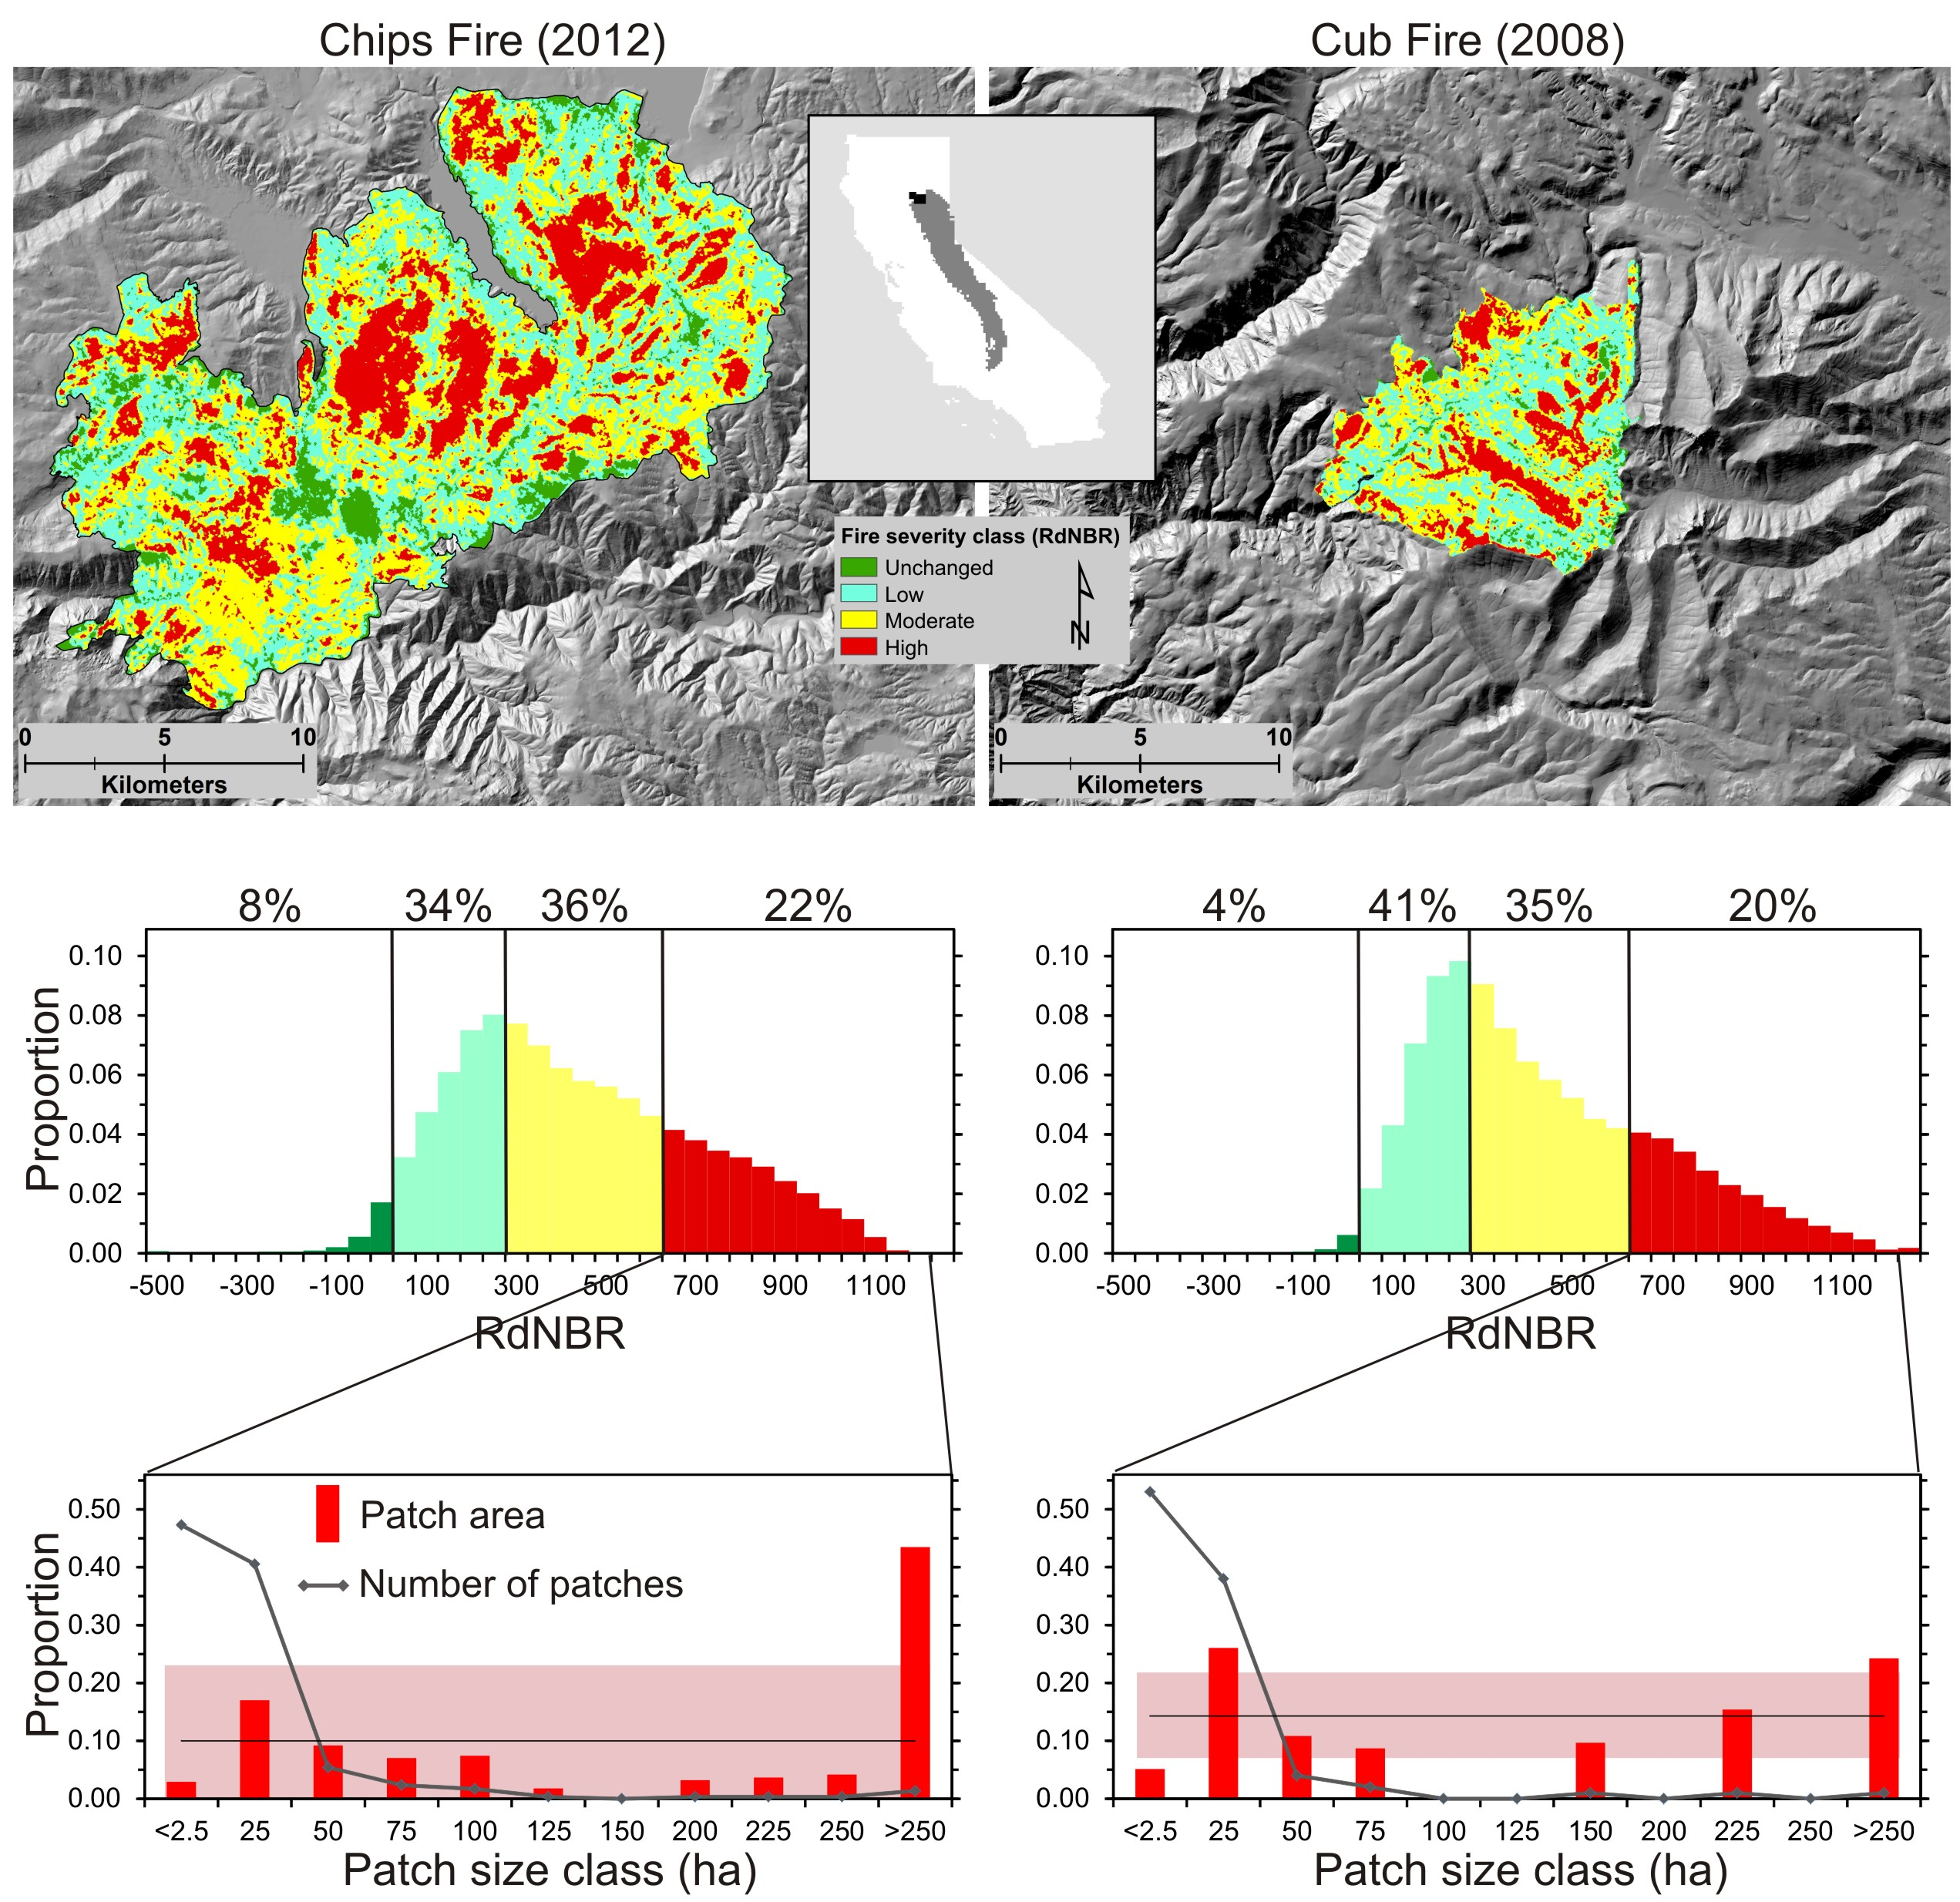

Figure 2.

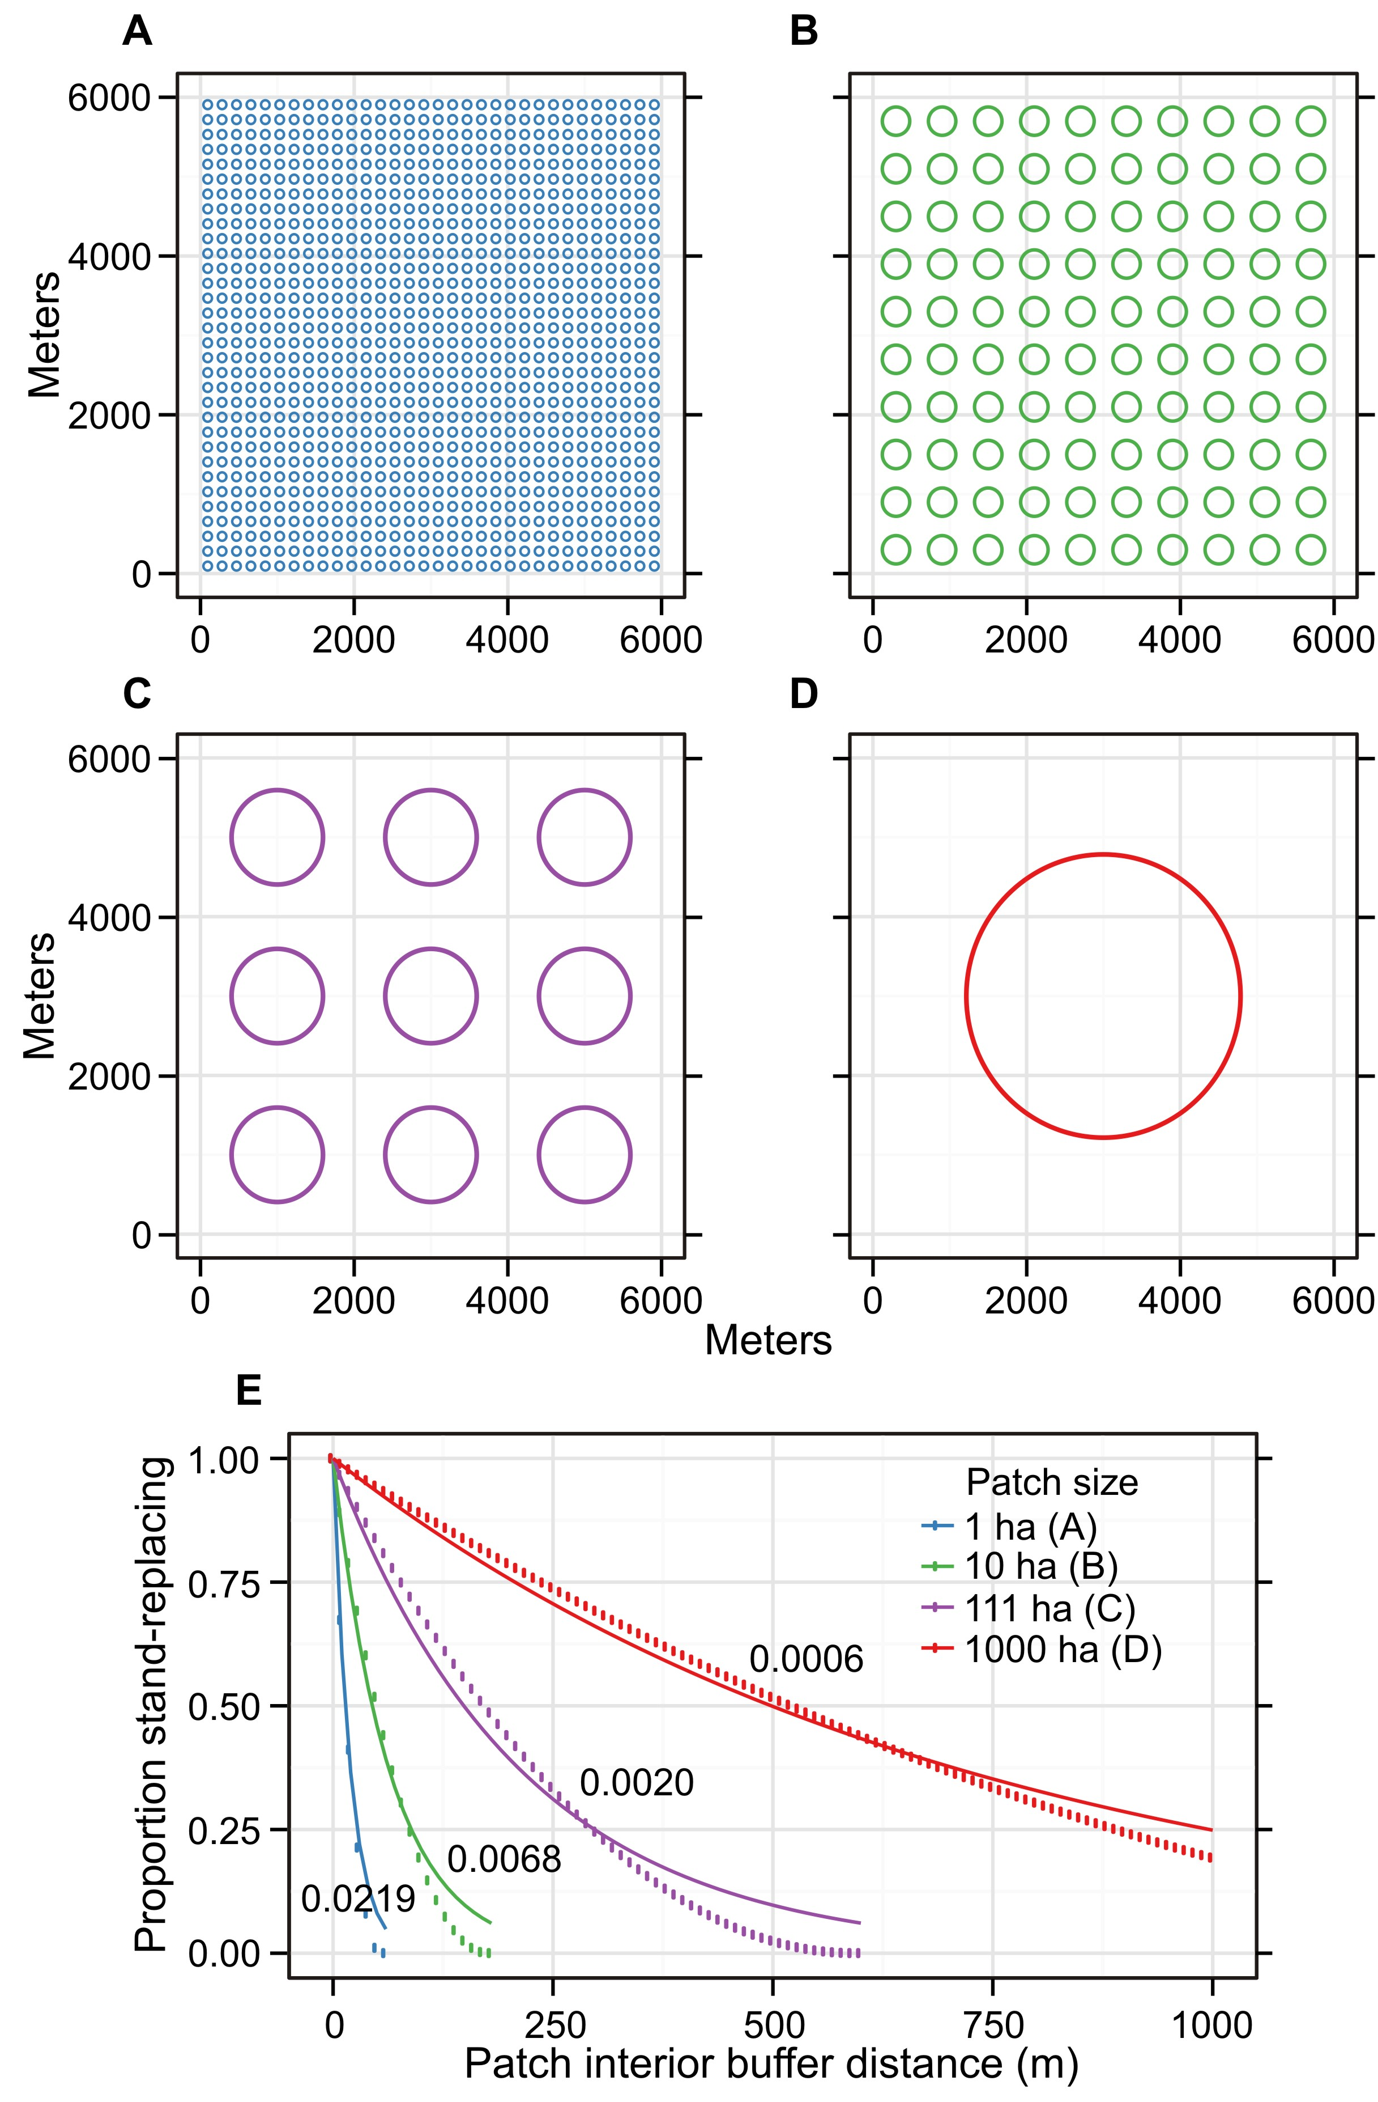

Figure 3

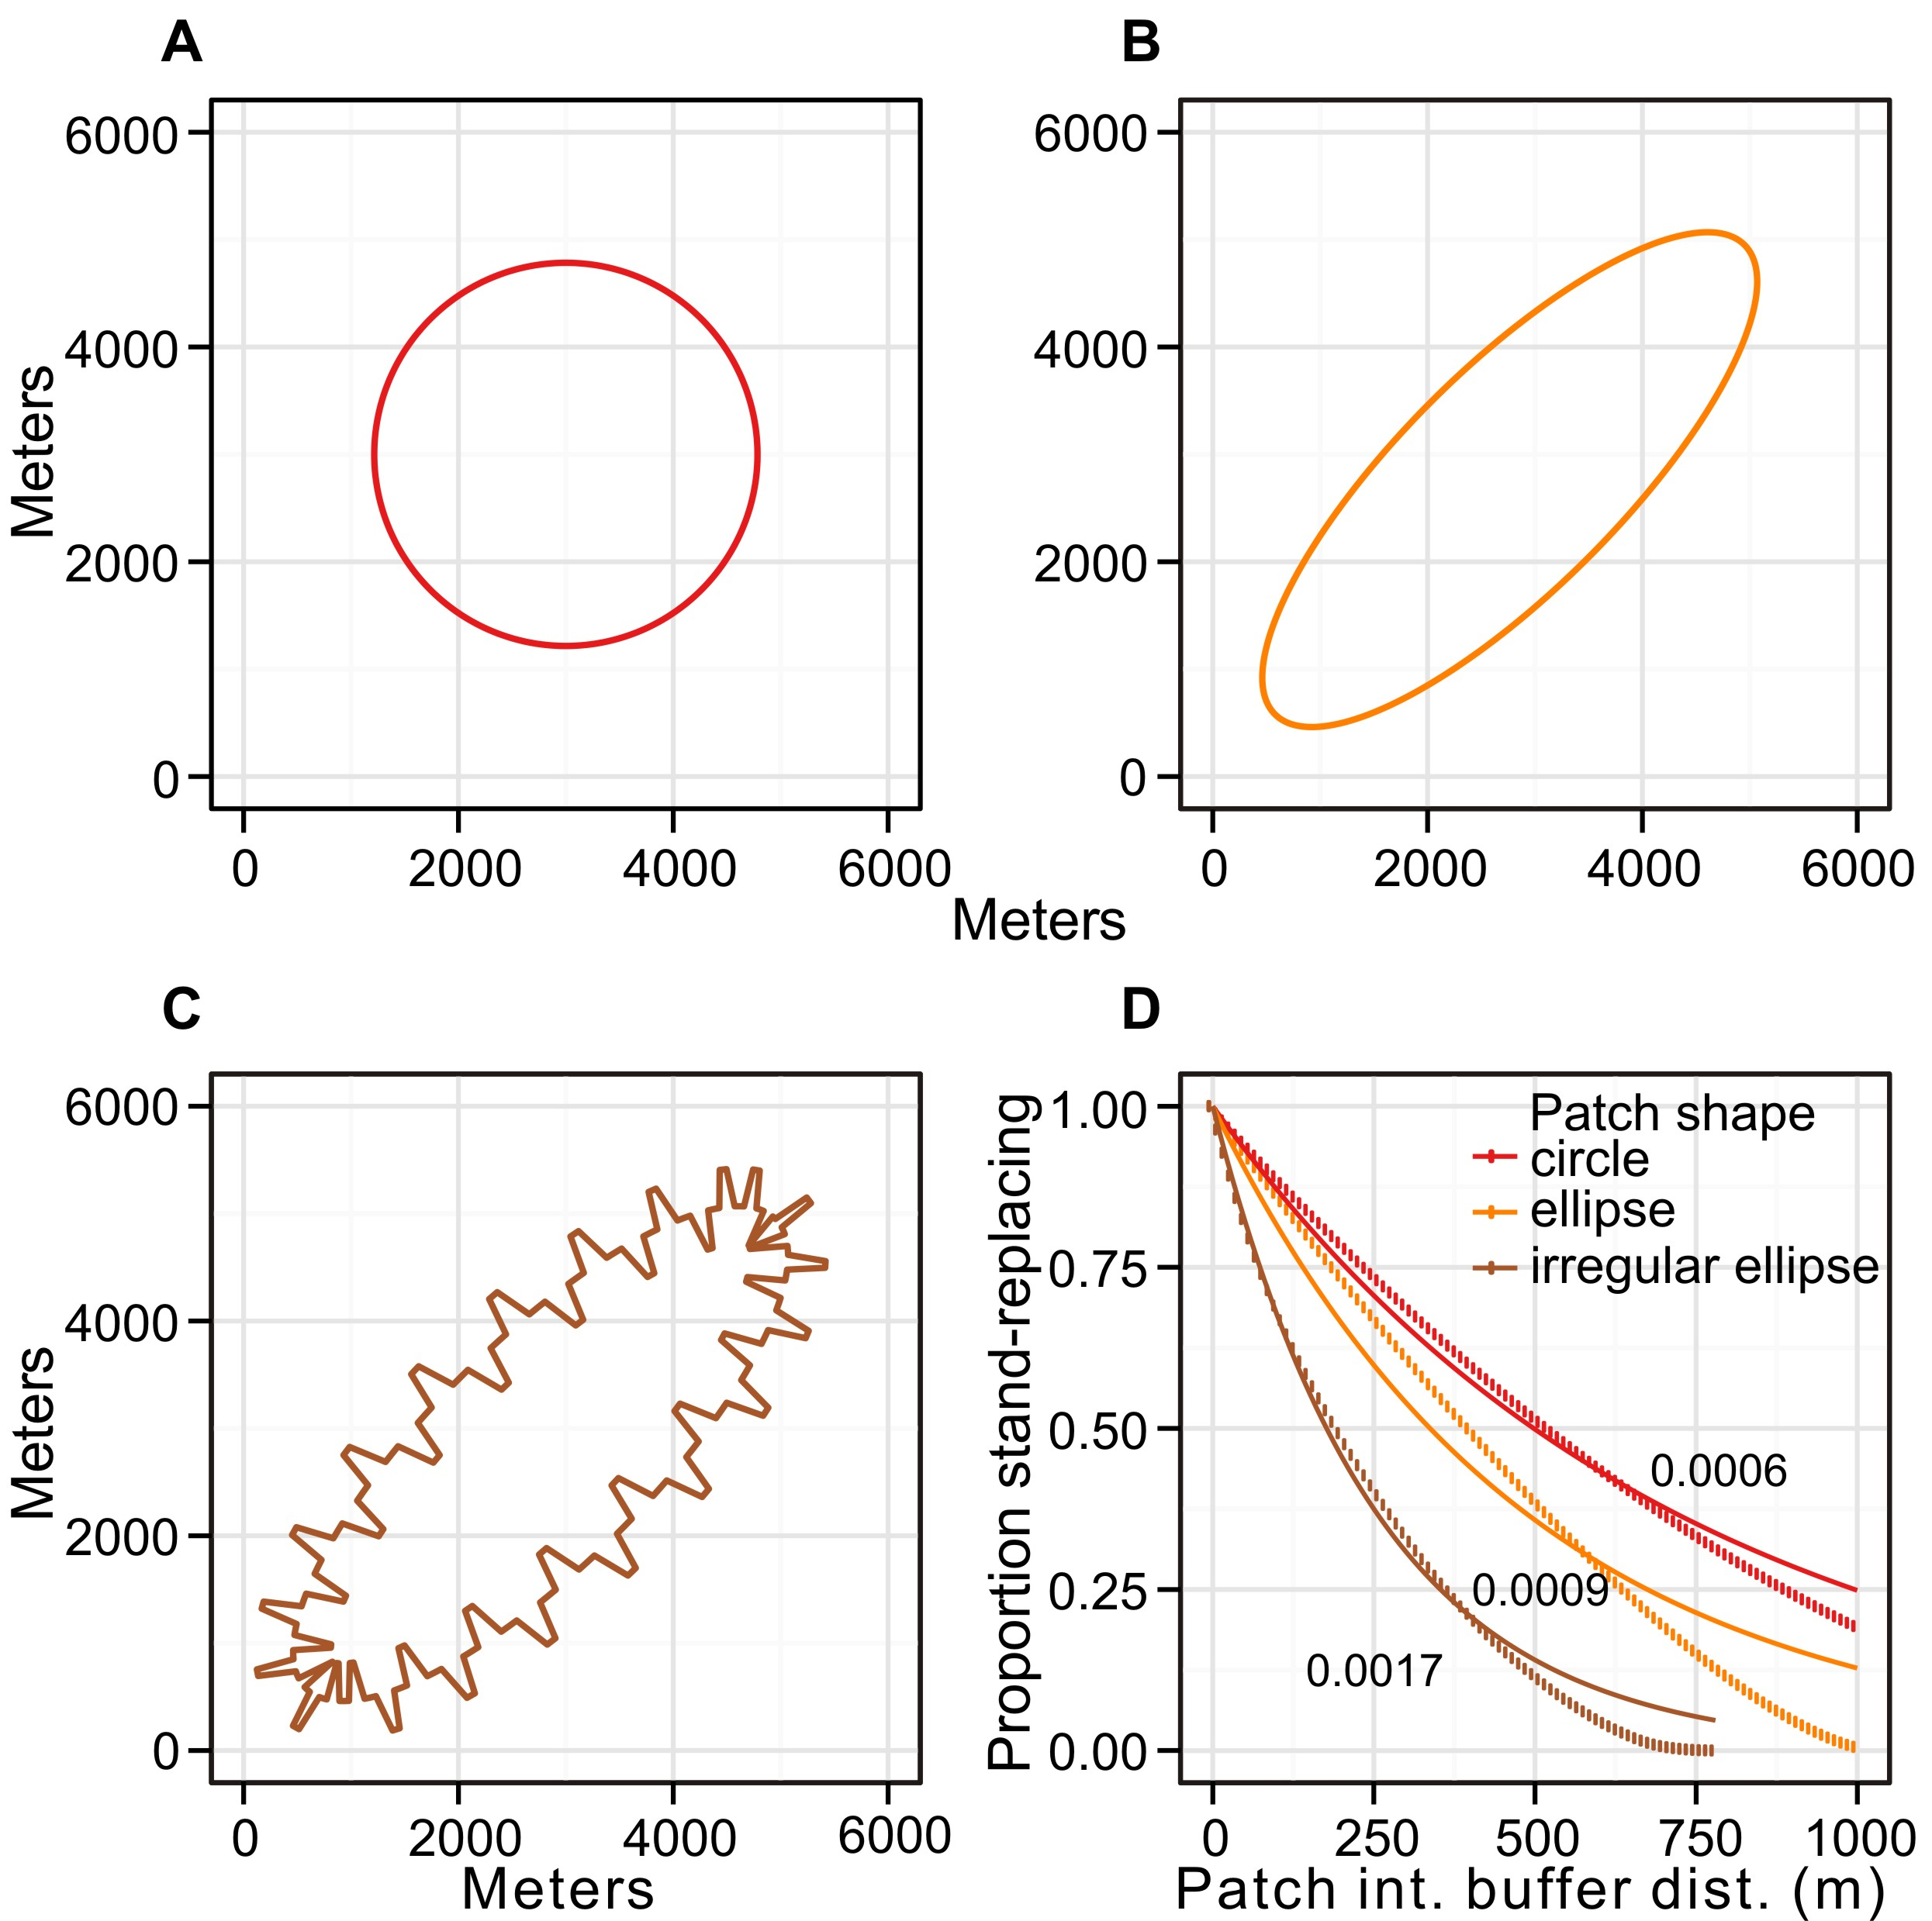

Figure 4.

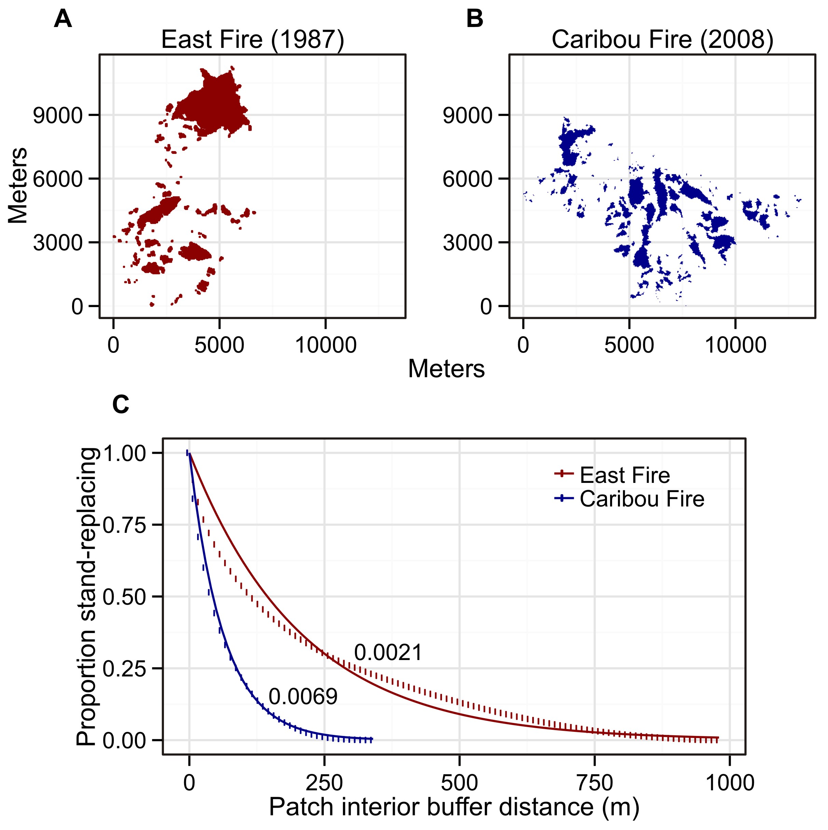

Figure 5.

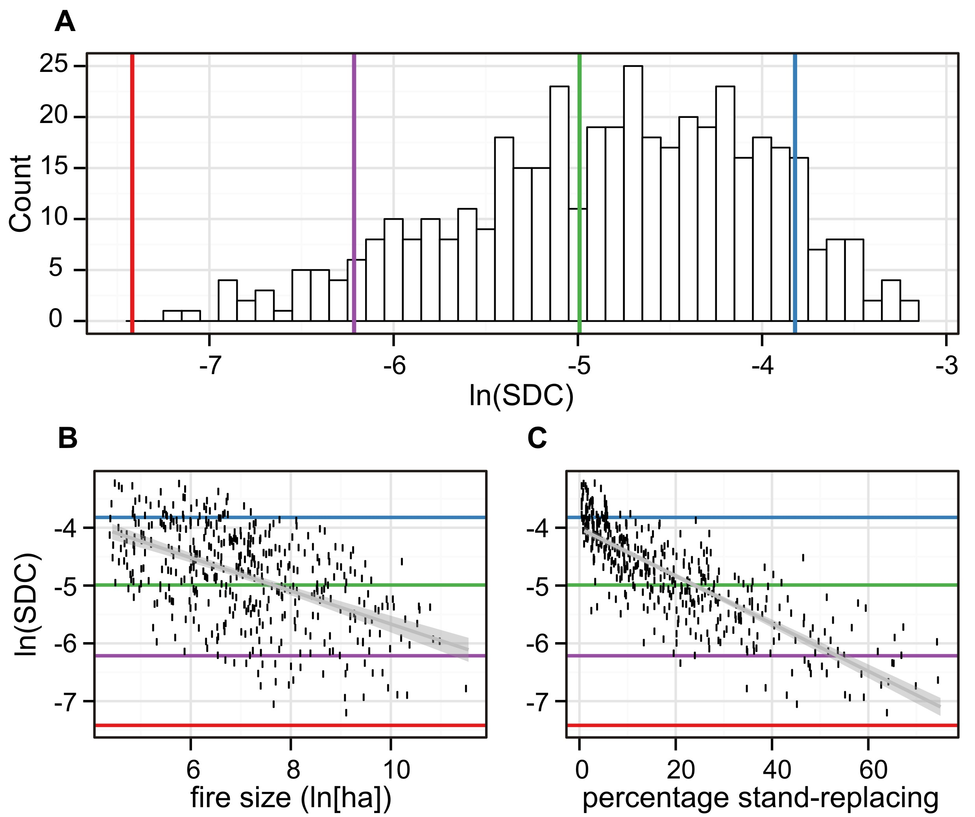

Figure S1. Proportion of stand-replacing patch area within different distance-to-patch-edge classes.

